**[](https://projectsubmission.boltiot.com/)Bolt IoT project submission**

**It’s Movie Time! Switch lights on dim with a click!**

* Post authorBy [rtkrrohit2021](https://projectsubmission.boltiot.com/author/rtkrrohit2021/)

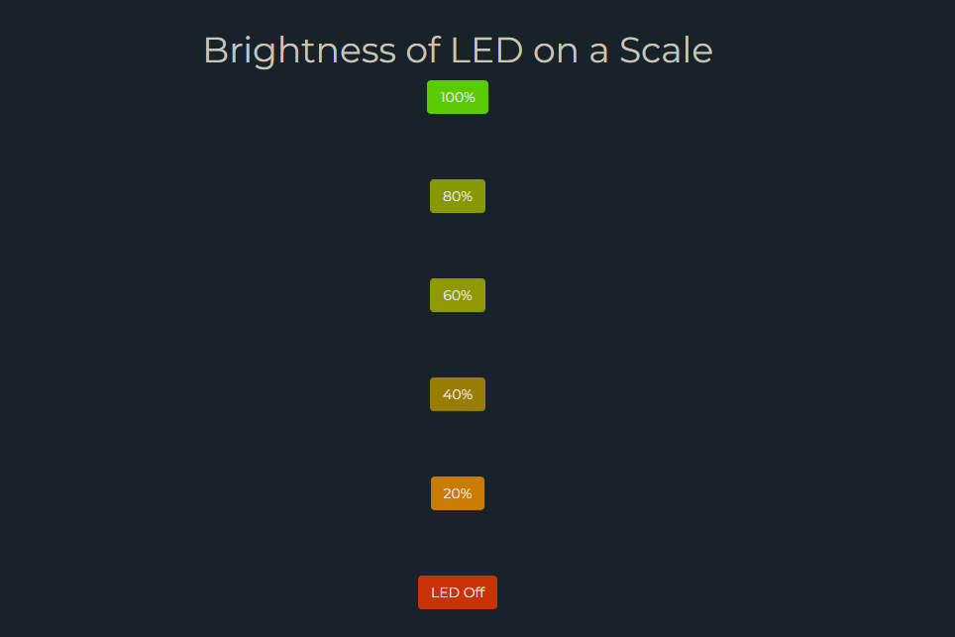Adjust the brightness at the click of your fingers!

**Problem Instance**

Consider that you are using your laptop to watch a movie and that you want to dim the lights as per your wish to create the atmosphere of a movie theater. What if you could accomplish the same thing while seated in bed with only one click? Doesn’t it look amazing?

Therefore, we will learn how to create code for the LED in this project, that will allow you to have a remote-control interface for the lights in your room.

**Components used in this project**

**Hardware components**

* BOLT Wi-Fi module

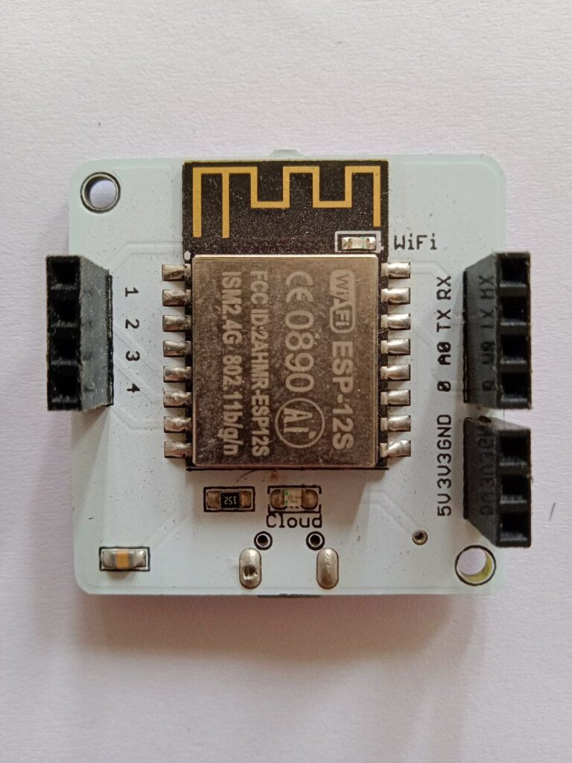

* Resistor

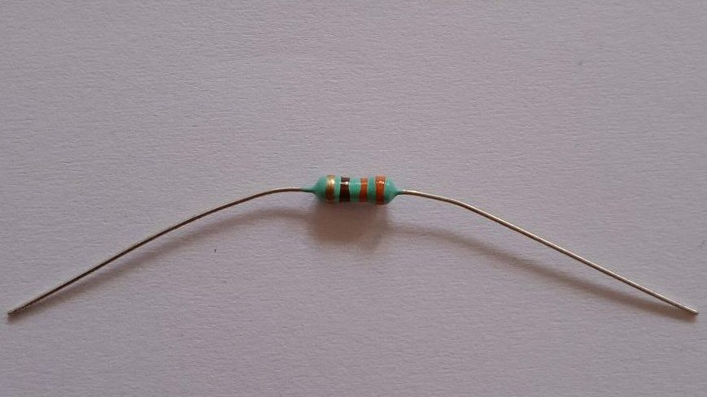

* LED

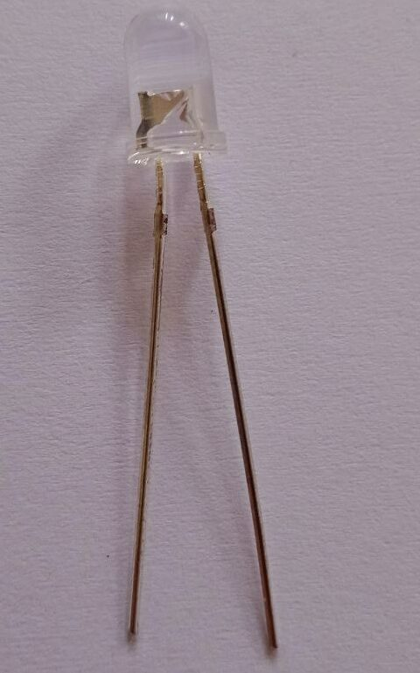

* Mobile adapter
* Mobile/PC as the controller

All the above components are included in the BOLT IOT/ML training starter kit.

**Software components**

* BOLT cloud



* Javascript development



**What this device will help you with?**

This device when deployed will help you with the following: -

* Energy Efficiency: Lowering the intensity when full brightness is not required helps save energy and extends the lifespan of the LEDs.
* Accessibility: For people with mobility issues or disabilities, remote control LED intensity provides easy access to adjust lighting without the need to move around physically.
* Mood and Ambiance: Remote control LED intensity lets you set the perfect ambiance for different occasions and moods.

**Hardware Setup**

Following is the LED circuit connection: -

* Connect the longer LED leg (positive terminal) to one of the legs of the resistor.
* Connect the other leg of the resistor to the GPIO pin 0.
* Connect the negative leg of the LED to the GND pin.

The circuit diagram is shown below: -

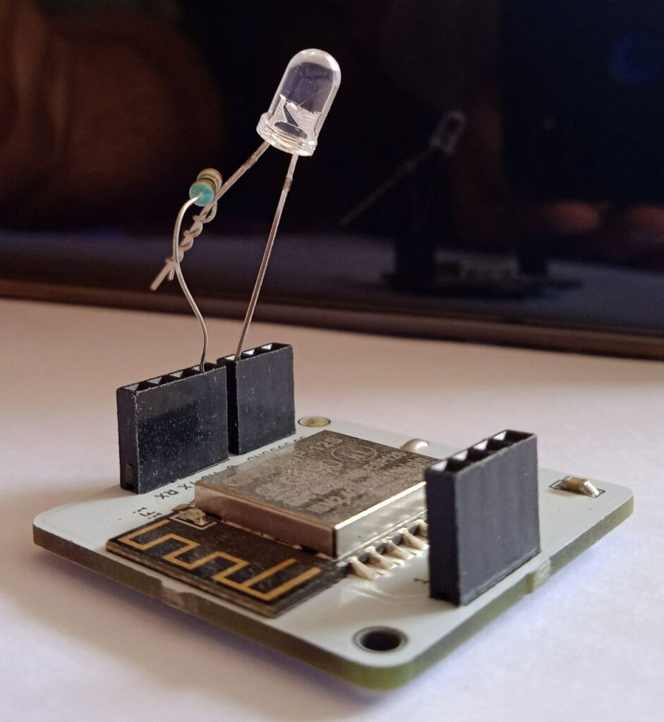

**Software programming**

Now we will make the user interface for the LED remote controller. For this, we shall use Javascript and API calls to our BOLT Wi-Fi module.

**Create a product on the BOLT cloud**

* Login to your Bolt cloud and create a new product.
* Since the LED is an output device, so select the “output devices” option.

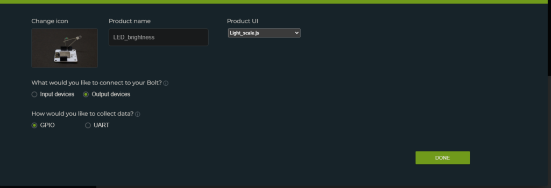Give the product name and other specifications.

**Configure the project**

We shall configure the product by clicking on the icon shown: -

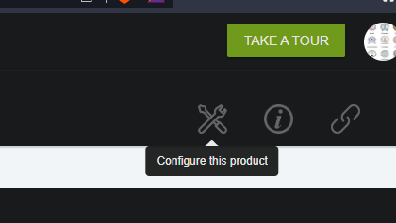

Click on the “Configure this product” button.

* There is no hardware configuration required for this LED Intensity controller product.
* Move to the “Code” tab and write the code provided below.

**Walkthrough of the Code**

The following code is written in JavaScript and adds some UI elements for the controller.

* For the user interface, we need a heading to prompt out the purpose of the controller. Thus, there are four lines of code to display formatted heading.
* Further below, the code uses “singleButton(…)” function to display user interactive buttons pertaining to different scales of brightness.
* Following is the description of singleButton() function’s parameters:-
  + name: the name of the button that will appear on the page. We want the display text to speak out of the LED brightness percentage.
  + pin: Specify the pin number to which you want to send the API calls using the BOLT cloud. For our case, we are using GPIO pin no. 0.
  + action: action button is the name of the command that will be executed at the click of the button. The commands are of two types, namely “digitalWrite” and “analogWrite”. These commands internally use API calls.
  + value: The value for the LED intensity. In the case of “digitalWrite”, the value is either “LOW” or “HIGH”. For “analogWrite”, the values can be anything from the set {0,1,2,..,255}.

As we want to be able to set the values of LED’s brightness in percenntage, we shaall use “analogWrite” command as that would allow us to give “value” parameter in the range [0,255]. So with some calculative analysis, we shall find the appropriate value for intensity that achieves the desired percentage.

* Other parameters are added for styling purposes:-
  + bgcolor: to specify the background color of respective button
  + shape: to specify the shape of the button, here “rectanngle”
  + align: to specify the alignment of buttons on the page, we have aligned the buttons “center”.
  + text_color: to specify the color of label text displayed on the button.
* Our objective was to have equal distribution between full intensity and zero intensity states of LED, so we chose the interval bin size of 20%, and provided the user with brightness controls of “LED Off”, 20%, 40%, 60%, 80% and 100%. Thus, we got 6 buttons to code the UI part for this project. So, divide 255 into 6 bins (from 0 to 255), so the bin size shall be (255)/5 = 51 each.

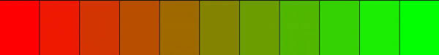The background color of the buttons is picked from this color range

The values of LED intensity are 0, 51, 102, 153, 204, and 255 respectively for the percentages 0%, 20%, 40%, 60%, 80%, and 100%.

//Heading code

const heading = document.createElement('h1');

heading.textContent = 'Brightness of LED on a Scale';

heading.style.textAlign = 'center';

document.body.appendChild(heading);

//brighness scale Buttons and api calls using built in functions from bolt cloud

//Button for switching the LED "On" at 100%

singleButton({name:"100%", action:"analogWrite", pin:"0", value:"255",bgcolor:"#40ff01", shape:"rectangle",align:"center","text_color":"white" });

//Change the brighness to 80%

singleButton({name:"80%", action:"analogWrite", pin:"0", value:"204", bgcolor:"#d8ff01", shape:"rectangle", align:"center", text_color:"white"});

//Change the brighness to 60%

singleButton({name:"60%", action:"analogWrite", pin:"0", value:"153",bgcolor:"#efff01", shape:"rectangle", align:"center","text_color":"white" });

//change the brightnness to 40%

singleButton({name:"40%", action:"analogWrite", pin:"0", value:"102",bgcolor:"#ffd101", shape:"rectangle", align:"center", text_color:"white"});

//change the brightnness to 20%

singleButton({name:"20%", action:"analogWrite", pin:"0", value:"51",bgcolor:"#ff9c01", shape:"rectangle", align:"center", text_color:"white"});

//Switch off the LED

singleButton({name:"LED Off", action:"analogWrite", pin:"0", value:"0",bgcolor:"#fd4001", shape:"rectangle", align:"center", text_color:"white"});

* Save the changes and then the product is ready to shoot.
* To view on a PC/laptop, use the “view this device” button

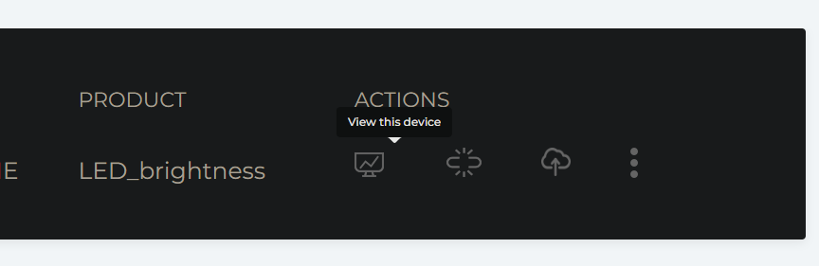

On clicking the button, the below page opens up

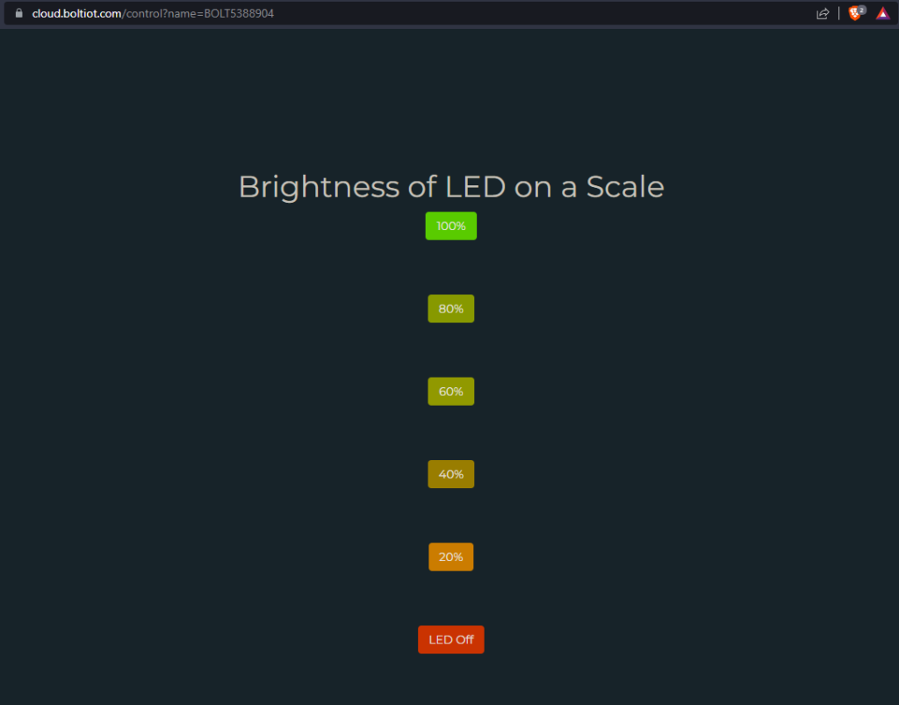

To view on your mobile device, simply open the BOLT IOT app on your smartphone to which you have linked your BOLT WiFi module. Select your bolt device and the controller is at your service.

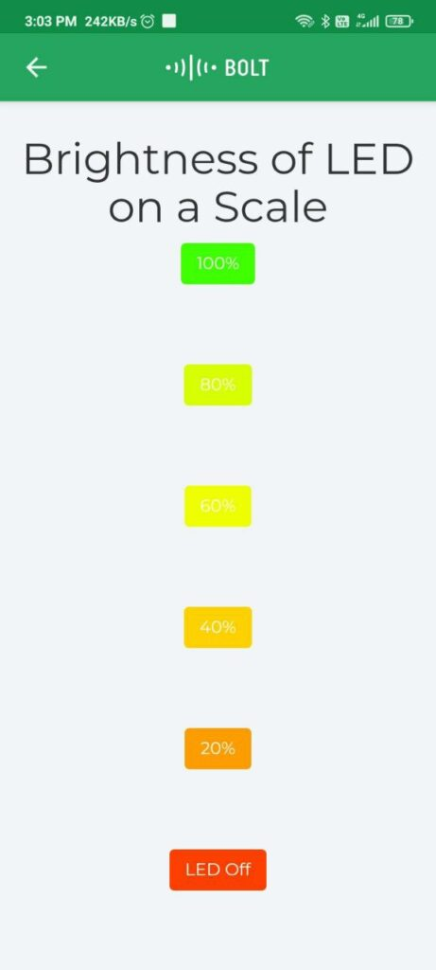

Select the brightness level to soothe your eyes.

**Controller in action**

Now the project is all ready, and here are the working pictures of this wonderful device: -

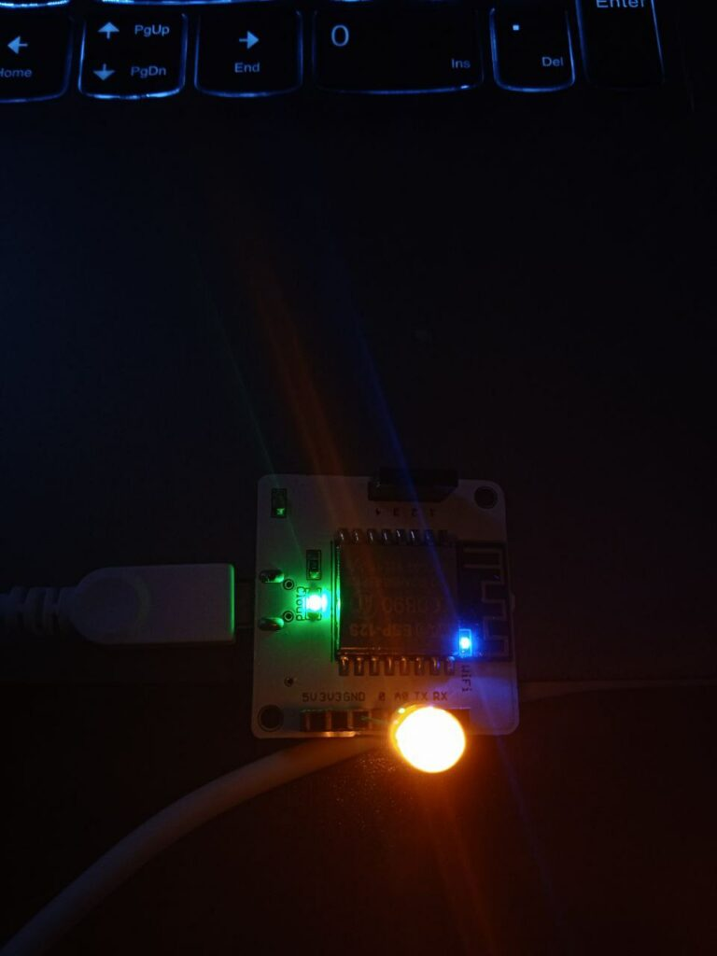 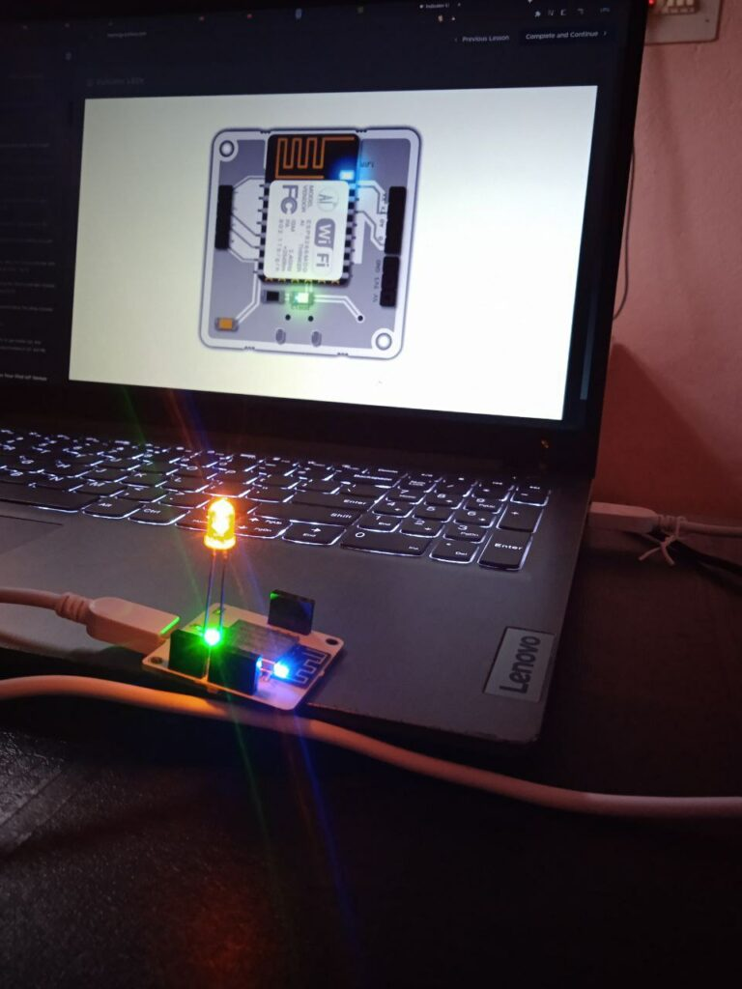

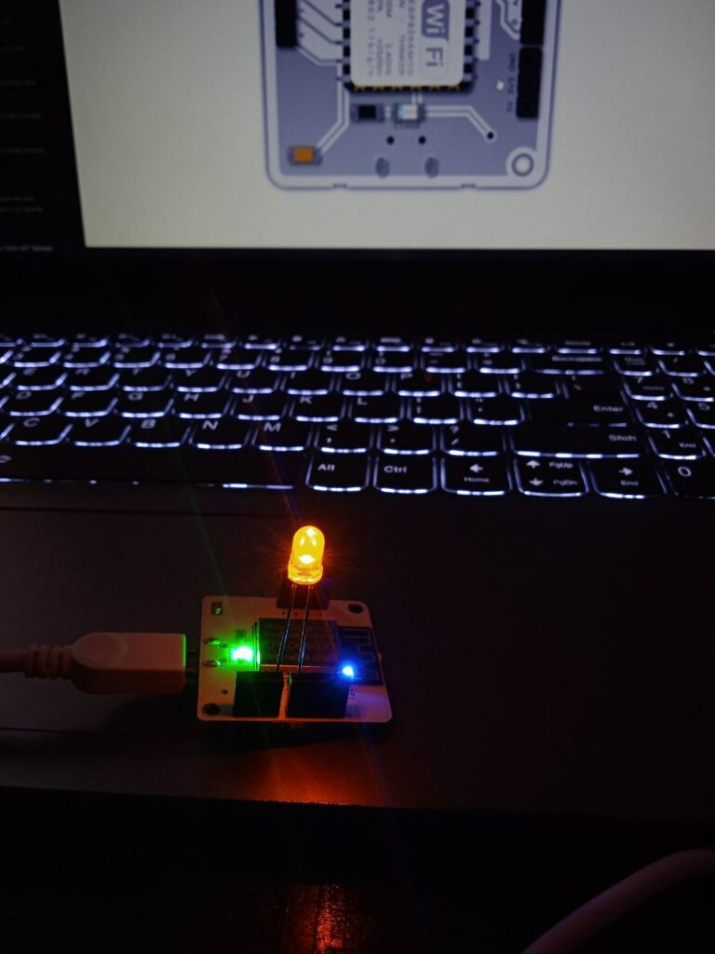

**Video Demo**

**Conclusion**

Thus, we have been able to build a full LED Intensity remote controller product which we shall use to control the brightness of the lighting in our homes without the need to move around. Get our product on your smartphone, and control your home lighting easily and effectively.